Lab 3 - Tableau
Name: eamonn kelly
Student number = D24127620

The following is my submission for Lab 3 – Tableau

Q1. What years did the museum acquire (buy or via donations) the most art?

Answer:

Tableau link =
https://public.tableau.com/app/profile/eamonn.kelly1417/viz/Lab3-Q1-NumberofArtAquisitionsperYear-Top5HighlightedinYellow/Q1-ArtObjectsAquiredperYear?publish=yes

Screenshot:

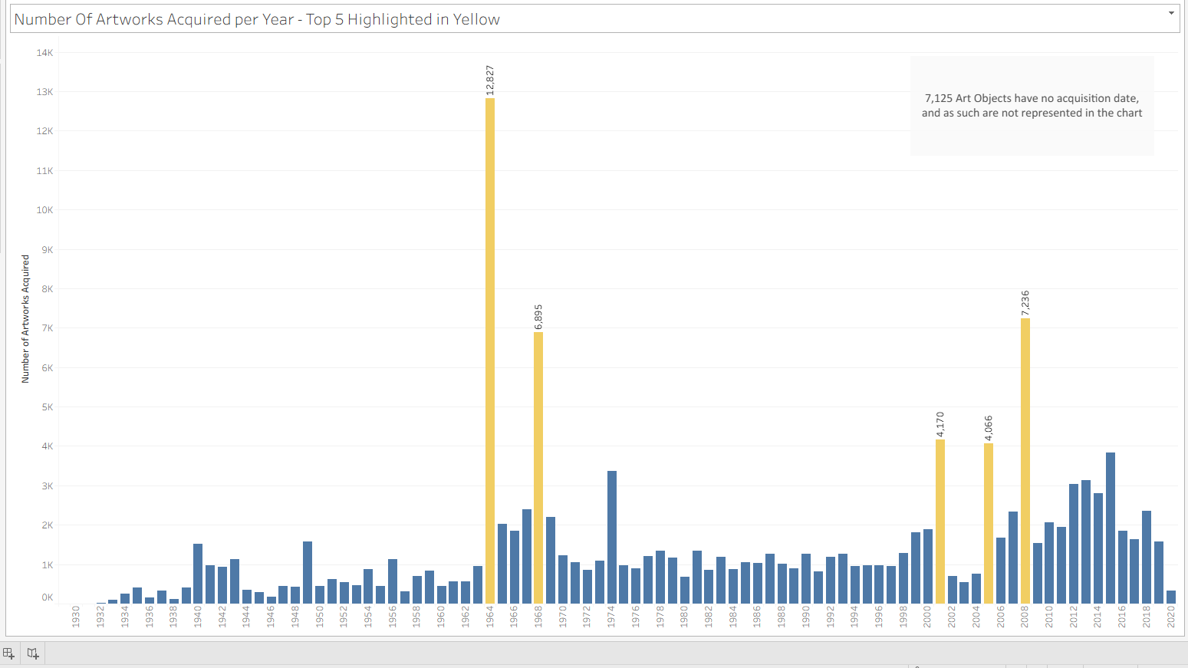

- We used “Date Acquired” field to account for when an art work was acquired regardless of how the acquisition took place.

Q2. Can you identify why there was such an increase in art pieces acquired during these years?

Answer
A significant increase in bequests and gifts in those years accounted for the increase in art object acquisition.

Tableau link =
https://public.tableau.com/app/profile/eamonn.kelly1417/viz/Lab3-Q2-NumberofArtAquisitionsperYearHowtheywereAcquired/Q2-howacquired?publish=yes

Screenshot:

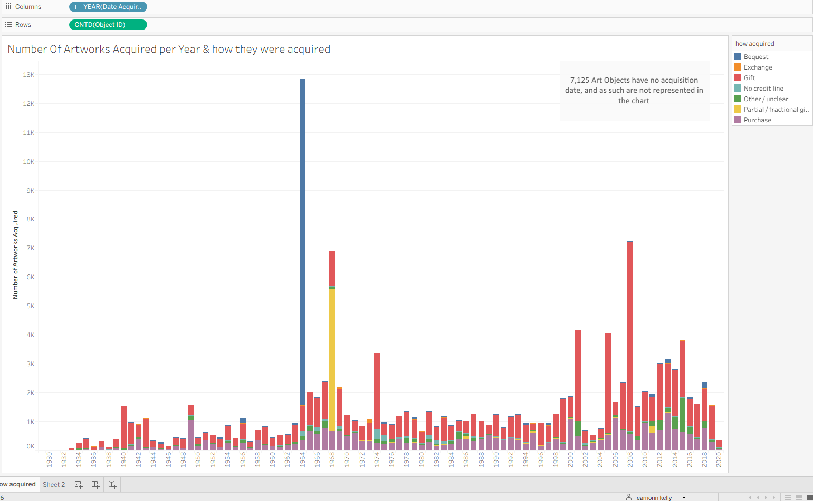

- The increase in the years where there as a significant increase in number of artworks acquired can be accounted for by a significant increase in bequests and gifts in those years.

Q3. What department has the most artwork?

Answer
The Drawings & Prints Department has the most Artworks.

Tableau link =

https://public.tableau.com/app/profile/eamonn.kelly1417/viz/Lab3-Q3-NumberofArtworksperDept-DrawingsPrintsDepthasthemostArtworks/Q3-NumberofArtworksperDept?publish=yes

Screenshot:
